Lab 4 – Flutter UI Fundamentals
1. Objective
This lab helps students practice building user interfaces using Flutter’s core widget system.
Students will learn how to work with basic widgets, input controls, layout structures, navigation scaffolding, and design polish techniques such as spacing and theming.
This lab corresponds directly to Module 4 – Flutter UI Fundamentals.
2. Requirements
Complete five exercises covering the main UI concepts:
1. Core Widgets (Text, Image, Icon, Card, ListTile)
2. Input Widgets (Slider, Switch, RadioListTile, Pickers)
3. Layout Composition (Column, Row, Padding, ListView)
4. Building Screen Structure using Scaffold
5. Applying ThemeData + fixing common UI errors
All tasks must:
· Compile and run in Android Studio / VS Code / DartPad
· Produce visible UI output
· Include comments explaining code
· Include screenshots (if required by instructor)

3. Guided Steps

Exercise 1 – Core Widgets: Text, Image, Icon, Card, ListTile
Goal: Build a simple UI demonstrating essential Flutter display widgets.
import 'package:flutter/material.dart';

class CoreWidgetsDemo extends StatelessWidget {
const CoreWidgetsDemo({super.key});

@override
Widget build(BuildContext context) {
return Scaffold(
appBar: AppBar(
title: const Text('Exercise 1 – Core Widgets'),
),
body: SingleChildScrollView(
padding: const EdgeInsets.all(16.0),
child: Column(
crossAxisAlignment: CrossAxisAlignment.start,
children: [
// 1. Headline Text
const Text(
'Welcome to TOKYO',
style: TextStyle(
fontSize: 28,
fontWeight: FontWeight.bold,
),
),
const SizedBox(height: 16),

// 2. Material Icon
const Center(
child: Icon(
Icons.location_city_rounded,
size: 80,
color: Colors.blue,
),
),
const SizedBox(height: 16),

// 3. Image from Network
ClipRRect(
borderRadius: BorderRadius.circular(8),
child: Image.network(
'https://images.unsplash.com/photo-1540959733332-eab4deabeeaf?auto=format&fit=crop&w=1200&q=80',
height: 180,
width: double.infinity,
fit: BoxFit.cover,
errorBuilder: (context, error, stackTrace) =>
const Icon(Icons.broken_image, size: 50),
),
),
const SizedBox(height: 16),

// 4. Card with ListTile
Card(
elevation: 2,
shape: RoundedRectangleBorder(
borderRadius: BorderRadius.circular(12),
),
child: const ListTile(
leading: Icon(Icons.star, color: Colors.amber),
title: Text('Movie Item'),
subtitle: Text('This is a sample ListTile inside a Card.'),
),
),
],
),
),
);
}
}

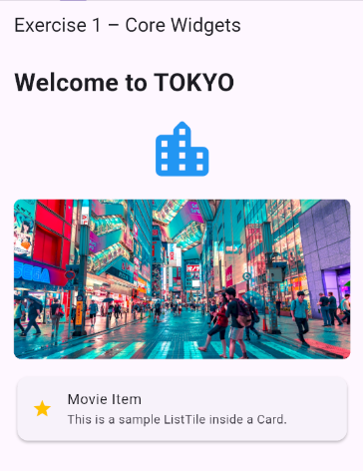

Exercise 2 – Input Widgets: Slider, Switch, RadioListTile, DatePicker
Goal: Build interactive UI that lets users control values.
Steps
1. Create a StatefulWidget named InputControlsDemo.
2. Implement a Slider, Switch, and RadioListTile group.
3. Add a button that shows a DatePicker when tapped.
4. Display updated values on screen.
import 'package:flutter/material.dart';

class InputControlsDemo extends StatefulWidget {
const InputControlsDemo({super.key});

@override
State<InputControlsDemo> createState() => _InputControlsDemoState();
}

class _InputControlsDemoState extends State<InputControlsDemo> {
double _ratingValue = 50.0;
bool _isMovieActive = false;
String? _selectedGenre;
DateTime? _selectedDate;

// Hàm mở DatePicker
Future<void> _pickDate() async {
final DateTime? picked = await showDatePicker(
context: context,
initialDate: DateTime.now(),
firstDate: DateTime(2025),
lastDate: DateTime(2026),
);
if (picked != null) {
setState(() {
_selectedDate = picked;
});
}
}

@override
Widget build(BuildContext context) {
return Scaffold(
appBar: AppBar(
title: const Text('Exercise 2 – Input Controls'),
),
body: SingleChildScrollView(
padding: const EdgeInsets.all(16.0),
child: Column(
crossAxisAlignment: CrossAxisAlignment.start,
children: [
// 1. Rating Slider
const Text('Rating (Slider)', style: TextStyle(fontSize: 18, fontWeight: FontWeight.bold)),
Slider(
value: _ratingValue,
min: 0,
max: 100,
divisions: 100,
label: _ratingValue.round().toString(),
onChanged: (double value) {
setState(() {
_ratingValue = value;
});
},
),
Text('Current value: ${_ratingValue.round()}'),
const SizedBox(height: 24),

// 2. Active Switch
const Text('Active (Switch)', style: TextStyle(fontSize: 18, fontWeight: FontWeight.bold)),
SwitchListTile(
title: const Text('Is movie active?'),
value: _isMovieActive,
onChanged: (bool value) {
setState(() {
_isMovieActive = value;
});
},
),
const SizedBox(height: 24),

// 3. Genre Radio Group
const Text('Genre (RadioListTile)', style: TextStyle(fontSize: 18, fontWeight: FontWeight.bold)),
RadioListTile<String>(
title: const Text('Action'),
value: 'Action',
groupValue: _selectedGenre,
onChanged: (value) => setState(() => _selectedGenre = value),
),
RadioListTile<String>(
title: const Text('Comedy'),
value: 'Comedy',
groupValue: _selectedGenre,
onChanged: (value) => setState(() => _selectedGenre = value),
),
Text('Selected genre: ${_selectedGenre ?? "None"}'),
const SizedBox(height: 24),

// 4. Date Picker Button
Center(
child: ElevatedButton(
onPressed: _pickDate,
child: const Text('Open Date Picker'),
),
),
if (_selectedDate != null)
Center(
child: Padding(
padding: const EdgeInsets.all(8.0),
child: Text('Selected Date: ${_selectedDate!.day}/${_selectedDate!.month}/${_selectedDate!.year}'),
),
),
],
),
),
);
}
}

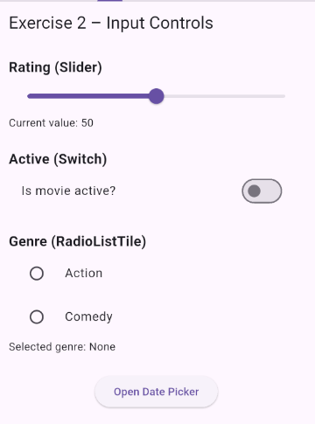

Exercise 3 – Layout Basics: Column, Row, Padding, ListView
Goal: Build a sectioned UI layout similar to a real app Home screen.
Steps
1. Use Column to create vertical sections.
2. Add spacing using Padding and SizedBox.
3. Add a ListView.builder showing movie titles or items.
4. Apply consistent spacing (8, 12, or 16 px).
import 'package:flutter/material.dart';

class LayoutDemo extends StatelessWidget {
const LayoutDemo({super.key});

final List<String> movies = const [
'Avatar',
'Inception',
'Interstellar',
'Joker',
'Avengers: Endgame',
'The Dark Knight'
];

@override
Widget build(BuildContext context) {
return Scaffold(
appBar: AppBar(
title: const Text('Exercise 3 – Layout Demo'),
),
body: Padding(
padding: const EdgeInsets.all(16.0), // Padding chuẩn 16px
child: Column(
crossAxisAlignment: CrossAxisAlignment.start,
children: [
const Center(
child: Text(
'Now Playing',
style: TextStyle(fontSize: 24, fontWeight: FontWeight.bold),
),
),
const SizedBox(height: 16), // SizedBox tạo khoảng cách 16px
Expanded(
child: ListView.builder(
itemCount: movies.length,
itemBuilder: (context, index) {
final movie = movies[index];
return Padding(
padding: const EdgeInsets.only(bottom: 12.0), // Khoảng cách giữa các item 12px
child: Card(
child: ListTile(
leading: CircleAvatar(
child: Text(movie[0]), // Lấy chữ cái đầu làm Avatar
),
title: Text(movie),
subtitle: const Text('Sample description'),
),
),
);
},
),
),
],
),
),
);
}
}
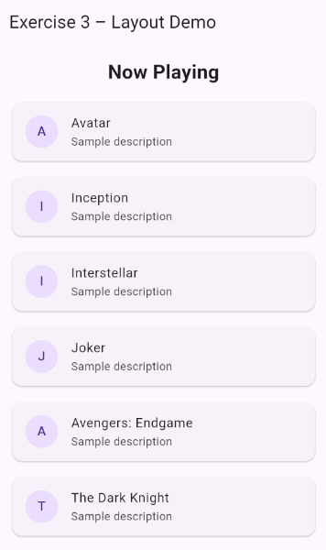

Exercise 4 – App Structure with Scaffold, AppBar, FAB & Theme
Goal: Practice building a complete screen structure.
Steps
1. Create a new screen using Scaffold.
2. Add:
o AppBar
o Body
o FloatingActionButton
o Theme customization using ThemeData
3. Implement a “Dark Mode” toggle using themeMode.
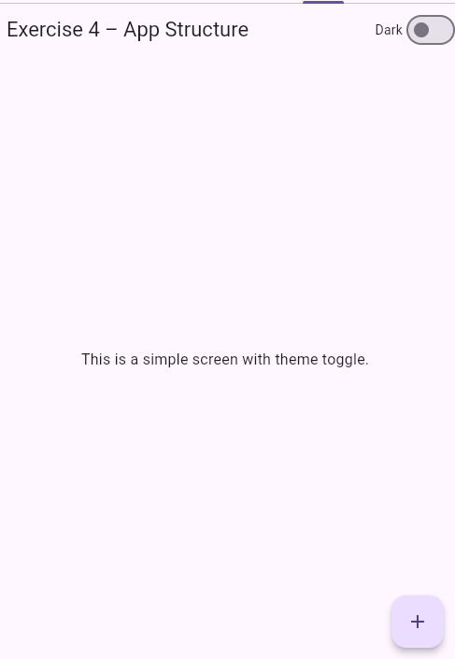
import 'package:flutter/material.dart';

class AppStructureThemeDemo extends StatefulWidget {
const AppStructureThemeDemo({super.key});

@override
State<AppStructureThemeDemo> createState() => _AppStructureThemeDemoState();
}

class _AppStructureThemeDemoState extends State<AppStructureThemeDemo> {
bool _isDarkMode = false;

@override
Widget build(BuildContext context) {
// Tạo ThemeData dựa trên trạng thái _isDarkMode
final themeData = _isDarkMode ? ThemeData.dark() : ThemeData.light();

return Theme(
data: themeData,
child: Scaffold(
appBar: AppBar(
title: const Text('Exercise 4 – App Structure'),
actions: [
Row(
children: [
const Text('Dark'),
Switch(
value: _isDarkMode,
onChanged: (value) {
setState(() {
_isDarkMode = value;
});
},
),
],
)
],
),
body: const Center(
child: Text(
'This is a simple screen with theme toggle.',
style: TextStyle(fontSize: 16),
),
),
floatingActionButton: FloatingActionButton(
onPressed: () {
ScaffoldMessenger.of(context).showSnackBar(
const SnackBar(content: Text('FAB Clicked!')),
);
},
child: const Icon(Icons.add),
),
),
);
}
}

Exercise 5 – Debug & Fix Common UI Errors
Goal: Understand common layout issues and fix them.
Tasks
1. Fix ListView inside Column using Expanded.
2. Fix overflow in small screens using SingleChildScrollView.
3. Fix state update issue by adding setState().
4. Fix DatePicker build context errors by calling from valid widget tree.
import 'package:flutter/material.dart';

class CommonUIFixesDemo extends StatefulWidget {
const CommonUIFixesDemo({super.key});

@override
State<CommonUIFixesDemo> createState() => _CommonUIFixesDemoState();
}

class _CommonUIFixesDemoState extends State<CommonUIFixesDemo> {
int _counter = 0;
DateTime? _selectedDate;

// Lỗi 4 Fix: Sử dụng BuildContext hợp lệ trong StatefulWidget
Future<void> _selectDate(BuildContext context) async {
final DateTime? picked = await showDatePicker(
context: context,
initialDate: DateTime.now(),
firstDate: DateTime(2020),
lastDate: DateTime(2030),
);
if (picked != null) {
// Lỗi 3 Fix: Bắt buộc dùng setState() để cập nhật lại UI
setState(() {
_selectedDate = picked;
});
}
}

@override
Widget build(BuildContext context) {
return Scaffold(
appBar: AppBar(
title: const Text('Exercise 5 – Common UI Fixes'),
),
// Lỗi 2 Fix: Bao bọc bằng SingleChildScrollView để chống lỗi tràn màn hình (Overflow)
body: SingleChildScrollView(
padding: const EdgeInsets.all(16.0),
child: Column(
crossAxisAlignment: CrossAxisAlignment.start,
children: [
const Text(
'Correct ListView inside Column using Expanded',
style: TextStyle(fontSize: 20, fontWeight: FontWeight.bold),
),
const SizedBox(height: 16),

// Lỗi 1 Fix: ListView bên trong Column phải dùng SizedBox có độ cao cố định
// hoặc bọc Expanded nếu nằm ngoài ScrollView
SizedBox(
height: 200,
child: ListView(
children: const [
ListTile(leading: Icon(Icons.movie), title: Text('Movie A')),
ListTile(leading: Icon(Icons.movie), title: Text('Movie B')),
ListTile(leading: Icon(Icons.movie), title: Text('Movie C')),
ListTile(leading: Icon(Icons.movie), title: Text('Movie D')),
],
),
),
const Divider(),

// Minh họa Lỗi 3 (State Fix)
Text('Counter: $_counter', style: const TextStyle(fontSize: 18)),
ElevatedButton(
onPressed: () {
// Phải bọc trong setState() thì UI mới biến đổi khi _counter tăng
setState(() {
_counter++;
});
},
child: const Text('Increment Counter'),
),
const SizedBox(height: 16),

// Minh họa Lỗi 4 (DatePicker Context Fix)
Builder(
builder: (validContext) => ElevatedButton(
onPressed: () => _selectDate(validContext),
child: Text(_selectedDate == null
? 'Pick Date'
: 'Date: ${_selectedDate!.day}/${_selectedDate!.month}/${_selectedDate!.year}'),
),
),
],
),
),
);
}
}
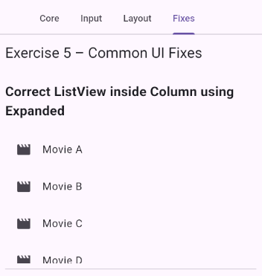
4. Expected Results
By completing this lab, students should be able to:
· Build UI using core Flutter widgets
· Handle input widgets and pickers
· Compose complex layouts using Column/Row/ListView
· Structure screens using Scaffold & Theme
· Identify and fix common UI mistakes
· Produce visible and runnable Flutter UI screens

5. Submission
· Source code for all 5 exercises
· Screenshots of UI output for each
· Short explanation for fixes in Exercise 5
· Submit via LMS or upload zipped project

